**THE TEENSY MICROCONTROLLER**

The teensy microcontroller series is a family of small powerful, microcontrollers which are suitable for fast embedded computing.

These microcontrollers are exceptionally good when it comes to audio interfacing.

They are programmed using Arduino IDE with the **Teensyduino** plugin.

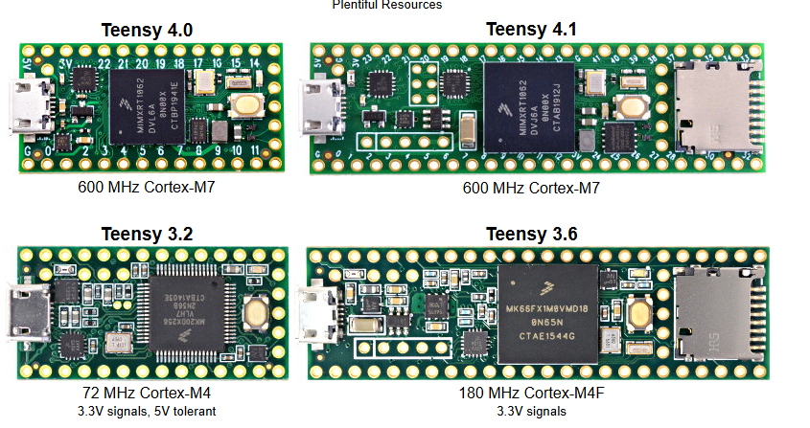

The most powerful models are the teensy 4.0 and 4.1 with the following specs;

**Teensy 4.0**

Processor: ARM Cortex-M7 @ 600 MHz

Flash: 2 MB

RAM: 1 MB (512K tightly coupled + 512K general)

GPIO: 40 pins (31 digital I/O, 14 analog inputs)

Interfaces: 3 UART, 3 SPI, 2 I2C, CAN, USB Host/Device

Size: 1.4" × 0.7"

**Teensy 4.1**

Processor: Same as 4.0 (Cortex-M7 @ 600 MHz)

Flash: 8 MB (external QSPI)

RAM: 1 MB + optional PSRAM

GPIO: 55+ pins, including Ethernet, microSD slot, and more serial interfaces

Expansion: 2 memory expansion sockets (PSRAM/Flash)

Size: 2.4" × 0.7"

**Special features**

Audio Library & Shield: Supports 44.1 kHz 16-bit audio with DSP filters, FFT, mixers, etc.

Real-Time Performance: Low-latency I/O, fast interrupts, and deterministic control.

Overclockable: Can be safely pushed to 720 MHz in some applications.

Power: Operates at 3.3V logic; draws more current than typical Arduino boards due to high speed.

**Why and where to use Teensy 4.0 or 4.1 microcontrollers in a LEO Satellite:**

1. The teensy microcontrollers are faster than a lot of microcontrollers including many Arduinos. With the speed of 600MHz, compared to the 16MHz speed of Arduino Uno, Arduino Nano and Arduino Mega. This makes them suitable for more complex computations and UHF communication.
2. They are equipped with useful Audio and digital signal processing (DSP) hardware which are helpful in vibration analysis, monitoring different sounds and signal processing. They are also suitable for data compression for transmission.
3. They have rich I/O and communication options. Teensy microcontrollers support UART, SPI, I2C, CAN, USB, PWM and ADC. A very important option is the SPI option which is fully supported and can be used for interfacing with long range communication (LoRa), which is an important communication aspect we can use for long distance communication such as in our LEO satellite.
4. Teensy microcontrollers support SD cards and this can be helpful when logging sensor data, audio files and images.
5. They are also small in size making them lighter for space and are cheap and affordable.

**Limitations**

1. It’s not space-rated. The teensy microcontroller is vulnerable to radiations and high space temperatures and hence not usually suitable for many space operations.
2. It does not have a built-in Bluetooth or Wi-Fi hence, in order to incorporate these capabilities, other modules are connected which increase the power drawn and complexity.
3. At 600MHz operation, it consumes more power hence may need custom power regulation.

In conclusion, due to it’s various features such as high speeds and advanced communication features, I can recommend the use of Teensy microcontrollers for communication, including receiving data from telemetry health sensors and Ground sensors, compressing the data and interfacing with communication modules like LoRa or LoRaWAN for transmission of the data over a wide area from space to the earth or back.

**TEENSY 3.2**

Microcontroller: NXP MK20DX256VLH7 (ARM Cortex-M4)

CPU Speed: 72 MHz (overclockable to 96 MHz)

Flash Memory: 256 KB

RAM: 64 KB

EEPROM: 2 KB

Operating Voltage: 3.3V (with 5V-tolerant inputs)

Input Voltage Range: 3.6V to 6.0V

USB: Micro USB (12 Mbit/sec, supports USB HID, MIDI, Serial, etc.)

Dimensions: 1.4" x 0.7" (35.56 mm x 17.78 mm)

**I/O and Peripherals**

Digital I/O Pins: 34

PWM Outputs: 12

Analog Inputs: 21

Analog Output: 1 (DAC)

UART (Serial Ports): 3

SPI Ports: 1

I2C Ports: 2

CAN Bus: 1

I2S Audio Interface: 1

DMA Channels: 16

Real-Time Clock (RTC): Yes

Touch Sensing Inputs: Available

**Why and where to use Teensy 3.2 microcontroller in a LEO Satellite:**

1. **Moderately Fast Processing Power**  
   The Teensy 3.2 operates at 72 MHz (overclockable to 96 MHz), which is significantly faster than many traditional Arduino boards (e.g., Arduino Uno, Mega at 16 MHz). While not as fast as Teensy 4.x, this speed is still sufficient for mid-level tasks like environmental sensor data processing, telemetry formatting, and basic communications such as UART or SPI interfacing with LoRa modules.
2. **Built-in Audio and DSP Capabilities**  
   Teensy 3.2 includes a 12-bit DAC and supports an audio library for basic signal processing tasks. While not as powerful as the Teensy 4.x in DSP, it still supports applications like sound detection, basic vibration analysis, or simple audio compression tasks — useful for payload diagnostics or acoustic monitoring.
3. **Rich I/O and Communication Options**  
   Teensy 3.2 supports multiple UARTs, SPI, I2C, PWM, ADC, and even CAN Bus — making it very flexible for LEO satellite subsystems. SPI is especially critical for interfacing with long-range communication modules like LoRa, a key asset for low-power, long-distance communication between satellite and ground.
4. **Support for SD Cards**  
   Teensy 3.2 can interface with SD cards via SPI, enabling local logging of telemetry data, environmental sensor readings, or captured images. This is useful for storing data during communication blackouts or scheduled downlink windows.
5. **Compact and Lightweight**  
   At only 35.56 mm x 17.78 mm, and weighing very little, Teensy 3.2 is ideal for space-constrained systems like CubeSats. It is also very cost-effective compared to more space-rated or high-end computing modules.

**Limitations:**

1. **Not Space-Rated**  
   Teensy 3.2 is a commercial-grade MCU not hardened against radiation or extreme temperature fluctuations, which poses a risk in the harsh environment of space. Proper shielding and error correction would be necessary for space missions.
2. **No Built-in Wireless Communication**  
   Lacking onboard Bluetooth or Wi-Fi, it requires external modules to add these capabilities, increasing system complexity and power usage — a challenge in power-limited space systems.
3. **Limited Processing Power and RAM**  
   With only 72 MHz CPU speed and 64 KB RAM, Teensy 3.2 is not ideal for compute-heavy operations like real-time image processing, advanced compression, or ML inference, which may be required for future LEO satellite missions.

**Conclusion:**

Teensy 3.2 is a practical choice for specific LEO satellite subsystems such as **sensor interfacing**, **basic data preprocessing**, and **communication module control** (e.g., LoRa telemetry). Its balance of size, power efficiency, and I/O capabilities make it well-suited for **non-critical onboard control and data acquisition tasks**. However, for more intensive computation or higher fault tolerance, **Teensy 4.0 or 4.1** would be better suited.